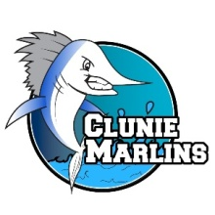
Swim-a-thon Pledge Form
Swimmer’s Name: _________________ Amount in envelope:_______
 | Sponsor’s Name | Per Lap Donation | Laps Swam | Pledge Total
1
2
3
4
5

--------------------EXAMPLE-------------------
Swimmer’s Name: Little Billy Amount in envelope: $146.00_
 | Sponsor’s Name | Per Lap Donation | Laps Swam | Pledge Total
1 | Billy’s Mom and Dad | $0.25 Per Lap | 60 | $15
2 | Billy’s Grandparents | ----- | ----- | $20
3 | Billy’s Rich Uncle | ----- | ----- | $100
4 | Billy’s Best Friend | ----- | ----- | $5
5 | Billy’s Neighbor | $0.10 Per Lap | 60 | $6

NOTE: We will begin collecting donations AFTER the lap count results are posted
Thank you for your support!
-Marlins Coaching Staff

